Katie's

Campfire Dinner Menu
Appetizers Dinner Plates
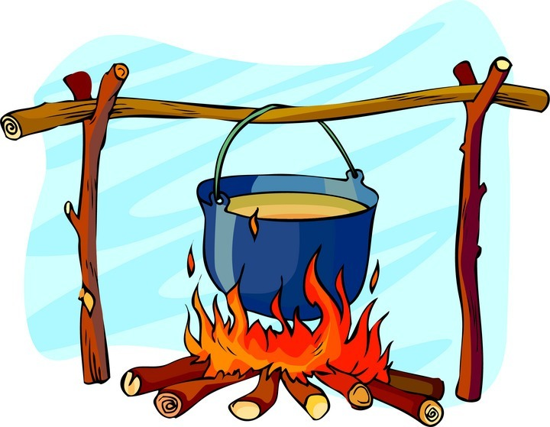
Wild West Shrimp 7.99 Comes with 2 sides & salad.
Pound of Grilled Shrimp mixed with our Chop Steak 9.50
Peppers and Jalapeno slices. Served 9oz Angus Beef with mushrooms, onions,
with Ranch. Peppers.
Texas Tonion 6.90 Roast Beef 8.50
Breaded Onion Straws served with our Pork Tenderloin with Gravy 9.85
Campfire Sauce. Chicken Fried Steak with Gravy 9.85
Chips and Salsa 3.99 Chicken Strips (4) 9.99
*Okra 3.75 Chicken Fried Chicken 8.99
*Onion Rings 4.20 8oz Grilled Chicken 8.99
*Fried Cauliflower 3.75 Red Rock Shrimp 8.99
*Fried Mushrooms 4.20 1 ½ pounds Grilled shrimp mixed with our 6 pepper
*Fried Green Beans 3.75 seasoning, jalapenos, peppers, and onions.
*Fried Jalapenos 3.75
Combo Roundup 8.50 Sides
Pick any three with an asterisk! Mashed Potatoes & gravy 1.95
Green Beans 1.50
Slim Pickin’s Corn 1.50
Under 500 calories French Fries 1.95
Grilled Chicken 7.50 Baked Potato (add 1.80 for loaded) 1.95
Served with Steamed Vegetables. 520 Cal Coleslaw 1.95
7oz Chopped Sirloin 8.99 Potato Salad 1.95
With Red Potatoes, Peppers, Onions, & grilled Cottage Cheese 1.95
mushrooms. 510 Cal You may choose Okra, Onion Rings, Fried Cauli,
Grilled Shrimp 7.50 Fried Mushrooms, Fried Green Beans, or
Grilled and served with Steamed vegetables. Fried Jalapenos for an additional 1.75 each
490 Cal

Don’t forget

DESSERT

Katie’s Lunch Corral

Sandwich Board & Fresh Angus Burgers (hand cut in house)
All Sandwiches are served with French Fries. Add extra $.05 each for lettuce, tomato, onion, or pickle. Add $1.50 extra for 1 piece of Bacon. Pepper Jack cheese is $1.00. Add cheese $.75
Grilled Cheese 5.00 Hamburger 7.15
BLT 5.99 Double Hamburger 8.75
Ham & Cheese 6.50 Cheeseburger 7.90
Chicken Strips (3) 7.35 Double Cheeseburger 9.20
Buffalo Chicken Strips (3) 7.90 Swiss Mushroom 8.25
Chicken Fried Steak 8.49 Rodeo Burger 9.49
Tenderloin 8.49 Smothered in cheese, BBQ sauce, Bacon,
Reuben 7.20 Patti Melt 8.65
Grilled or Fried Chicken 8.49 Wild West Burger 9.49
Comes with Swiss cheese. Smothered in pepper jack, BBQ sauce, Bacon
Philly Steak 7.99 & fried jalapenos
Onions, Peppers, Swiss Cheese Black and Bleu Burger 8.65
Turkey Club 8.90 6 pepper seasoning & bleu cheese
Smoked Turkey & Ham piled high with The Big D Burger 11.99
Bacon, lettuce, tomato, & cheese One pound of Angus as a double with bacon,
Salads & Wraps onion, lettuce, tomato, pickle, Pepper jack &
Choice of Dressings: Ranch, Fat Free Ranch American cheese, & one onion Ring
French, Italian, Honey Mustard, Poppy seed
Bailey’s Bundle 8.50
Half Sandwich with side salad

Balsamic Vinaigrette, Bleu cheese, 1000 island
Side Salad 3.99
Chef Salad (Ham & Roast) 8.50
Fried or Grilled Chicken Salad 8.50 Hot Open Faced Sandwich

Smoked Meat (Turkey & Ham) 8.50 Served with meat cut atop of mashed potatoes, bread
The Cruncher Salad 8.50 and smothered in gravy.
Chicken breast, grapes, feta cheese, walnuts, Chicken Fried Chicken, Roast Beef, Tenderloin,
Cranberries, raisons, & apples Chicken Fried Steak, or Hamburger
Turkey Twist 8.50 8.90
Turkey, bacon, sliced almonds, red onion, & feta Drinks
BLT Wrap 4.75 Pepsi, Diet Pepsi, Dr. Pepper, 1.90
Chicken Wrap 6.25 Pink Lemonade, Root Beer, Mountain Dew,
Fried or Grilled Chicken Sierra Mist, Diet Dr. Pepper
Fajita Wrap 6.25 Tea (Sweet or Regular) 1.75
Steak or Chicken, peppers, onions, cheese Check out our iced coffee & cappuccino’s! Ask
Buffalo Chicken Wrap 6.75 your server for flavors!!
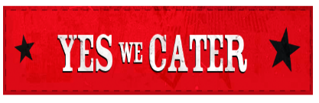
Wrap with a side 8.90
Eating raw or undercooked food may cause food borne illness
Katie’s Breakfast
All Omelets & Combo’s come with your choice of hashbrowns or cottage fries, & toast, biscuit, ¼ order biscuit & gravy, or a medium cake. All Skillets come with potatoes mixed in it so you choose your bread choice only.

Breakfast Favorites Combo’s
The Workin Man 7.45 1 egg 4.00
2 cakes, 1 egg, bacon or sausage 2 egg 4.75
The 1-2-3 Meal 5.50 Bacon or sausage 6.50
1 egg, 2 bacon or 1 sausage or ½ ham, Ham 7.25
& 3 mini cakes or 1 pc French toast Tenderloin with gravy 8.95
The Little Guy 7.30 Chicken Fried Steak with gravy 8.95
½ order biscuits & gravy, potato choice, 9oz Chopped Sirloin 8.95
And bacon or sausage
The Big Boy 8.95 Omelets
Full order of biscuits and gravy, potato Philly Steak 7.50
Choice, & bacon or sausage Western 7.50
The Little Lady 4.10 Ham & Cheese 7.00
¼ order biscuits & gravy, ½ potatoes, Bacon & cheese 6.75
½ bacon or sausage Sausage & cheese 6.75
Veggie & cheese 6.75
Breakfast Sandwiches Cheese 5.50
Add cheese .75. Comes on white, rye, Skillets
Wheat, muffin, or biscuit Chuckwagon 7.50
Egg only 2.50 Steak, peppers, onion, tomatoes,
Bacon or Sausage with egg 3.95 Egg whites, hashbrowns
Ham & egg 4.60 Tater Roundup 8.20
Biscuits & Gravy Ham, bacon, sausage, onion, peppers,
full order (2) 4.10 Scrambled egg, taters, cheese
½ order (1) 2.95 South of the Border 8.20
¼ order (1/2) 1.65 Steak, peppers, onions, jalapenos,
Cakes & More Taters, scrambled egg, cheese
1 cake 1.50 Breakfast Burrito 7.50
2 cakes 2.75 Comes with side of potatoes
3 cakes 3.25
½ French toast (2pc) 2.75
Full French Toast (3pc) 3.50
Cinnamon roll 3.00
Oatmeal 2.50 208 S. State Rt C Peculiar, MO 64078 816-779-1005
Grits 2.75 Eating raw or undercooked food may cause food borne illness

Side Items & Ala Carte Drinks
Bacon or Sausage 2.80 Coffee 1.45
Ham 3.10 Tea (Sweet or Regular) 1.75
Potatoes 1.95 Pop Kids 1.25 Reg 1.90
Egg 1.10 Pepsi, Diet Pepsi, Dr. Pepper, Diet Dr.Pepper,
Toast 1.25 Mountain Dew, Root Beer, Pink lemonade, Sierra Mist
Muffin 1.45 Cappaccino (check for flavors) 1.95
Fruit Cup 1.95 Iced Coffee 1.95
Applesauce 1.95 French Vanilla, Mocha, Caramel
Peanut Butter .75 Milk 1.35
Sour Cream .75 Chocolate Milk 1.80
Jalapenos .75 Juice 1.50
Cheese .75 Tomato, apple, grape, orange
Bowl Gravy .95 Hot Chocolate 1.50
Mushrooms 1.50
Salsa .75
Brown Sugar .75

Senior Menu
Any MEAL (not single item or ala cart) can be made into a
Senior meal. All Senior Meals are $1.25 OFF
the regular priced menu. Available for breakfast, lunch,
or dinner.

Shootin ya Straight!
Splitting meals
We do not allow meals to be split unless you upcharge for $2.00. Thanks for understanding!

Discounts
10% discount to all School Staff, Veterans, Police, Fire, & EMT.

Catering
Katie’s offers CATERING that can be delivered or picked up! Any size from 10-500. Please check out our catering menus! Personalized Menus are also available to fit your occasion.

Right to Refuse Service
At Katie’s we ask you to treat all employees and other customers as you would treat your momma! If you get rowdy we do have the right to show you the door!

Katie’s Buckaroo menu
All kids’ meals come with a small kids drink. Free refills on tea, lemonade, or soda only. 12 & under only.

Breakfast 3.10 Lunch & Dinner 3.50
Kids cake, 1 egg, 2 bacon or 1 sausage 1 chicken strip & fries
1 pc French Toast, 2 bacon or 1 sausage 2 chicken strips & fries 4.10
¼ Biscuit & Gravy, 2 bacon or 1 sausage Hamburger & fries
Toast, 1 egg, 2 bacon or 1 sausage Grilled Cheese & fries
Applesauce or fruit cup, 1 egg, toast Grilled Ham & cheese & fries
Cold Turkey & cheese & fries
